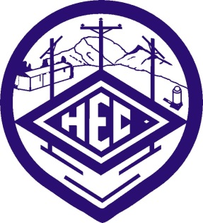

Harney Electric Cooperative, Inc.
PO Box 587
Hines, OR 97738-0587
t. (541) 573-2061
f. (541) 573-3930

Sharing Success Application 2022
Recipient Organization
__________________________________________________________________________
Recipient Organization Address
__________________________________________________________________________
Amount Requested
__________________________________________________________________________
CoBank will match a single gift between $1,000 and $10,000.
Maximum Total Donation is $20,000.

Intended Use of Gift (Please describe the program or intended use of the contribution.)
_____________________________________________________________________________________
_____________________________________________________________________________________
_____________________________________________________________________________________
_____________________________________________________________________________________
Please provide the following:
____ Proof of the designated recipient nonprofit organization’s 501(c)(3) status has been obtained. A copy of the IRS 501(c)(3) tax exemption notification MUST be included with the application.
OR:
______The recipient organization is not a 501(c)(3) charity. Its TIN (taxpayer identification number), also referred to as an EIN (employer identification number) is ____________________
____ A letter describing the project, the location of the project (verification of location within HEC territory), and how the project will benefit Harney Electric's membership and the cooperative.

Applications submitted to Co-Bank are considered on a first-come-first-serve basis as funds are available. The HEC donation is dependent upon the matching grant, and will not be made if the matching grant is not available. All applications should be received by August 31^{st.} However, HEC reserves the right to select a recipient before or consider applications received after this date.

